1. 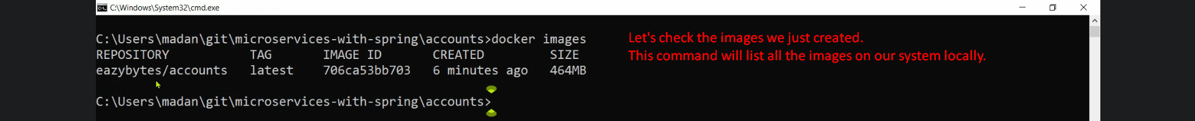
2. Text

   Description automatically generated
3. Graphical user interface, text, application, email

   Description automatically generated
4. Let’s see other Docker commands which are very helpful.
5. To see container running in the backend even though we pressed CRL + C on CMD to return to “Command Prompt”.
6. Commands:
   1. **docker ps**   
      first port is inner port in the container and second port is host OS port.
   2. 
7. So, you don’t need separate VM to create and run images and containers respectively for small microservice.
8. Advantages:
   1. Portability: If running on your system, will also run on other’s machine or on different environment.
   2. Scale Up or Down: Just running the docker run command will create one more instance of container to run app.